West Shore Lutheran School’s Summer School Age Program

Dear Families,

If you’d like for your child to attend the WSLS summer program, please be sure to complete and return the attached packet and $50 registration fee by Friday, April 26, 2024. Space is limited and will be available on a first-come, first-serve basis.

Important Dates:
Friday, April 26 - Summer registration paperwork and the fee is due
Monday, June 10 - Summer program begins for school-age students
Tuesday Faith Fun with Mrs. Appold - Specific dates will be announced later
6 Water Wednesdays - June 12 & 19, July 10, 17 & 24, August 14 from 12:30-1:45
6 Park Day Thursdays - June 13 & 20, July 11, 18 & 25, August 15
Friday, August 23 - Summer program ends for school-age students

Closures:
Thursday, July 4 - Closed for Independence Day Vacation
Friday, July 5 - Closed for Independence Day Vacation

Thank you for choosing West Shore Lutheran School for your summer child care needs. If you have any questions, please feel free to contact me via email, at wsls_childcare@hotmail.com or call 755-1048.

Thank you,

Lisa Serene
Child Care Director

SUMMER CHILDCARE AND SCHOOL AGE HOURS REQUEST FORM

The Center shall provide the following basic services for

____________________________ ______________________ ________________
(Child’s Name) (Date of Birth) (Gender)

Parent or Guardian information:

___________________________________ _________________________________
(Name) (Relationship)

___________________________________ _________________________________
(Address) (City/State/Zip)

________________________ _____________________________________________
(Phone) (Email address required for billing purposes)

_______________________________________________________________
(School District)

Days of the week childcare is needed: circle days and list hours. Start Date_______________

Monday From___________ To______________
Tuesday From___________ To______________
Wednesday From___________ To______________
Thursday From___________ To______________
Friday From___________ To______________

If your schedule needs to change please let us know in writing what your new childcare hours will be. We will make every effort to accommodate your needs. Childcare cost is currently $5.95 per hour. This rate is subject to change. If your child is sick or will not be attending childcare, please call 755-1048 or email Miss Lisa at wsls_childcare@hotmail.com by 9:00 AM to cancel that day or you will be billed for the hours listed above. Parent/Guardian agrees to all provisions above.

**There is a $50 nonrefundable summer registration fee required when submitting this form

____________________________________ ______________________
Signature Date
Summer Questionnaire 2024 - School Age Room

- What is your child’s name: ____________________________________________

- Please list what grade your child will be entering for the 24/25 school year: _____

- Please list your child’s 1st day of summer care: ____________________________
Please note: The last day of summer care for elementary school students is Friday, August 23.

- Does your child have any food allergies? If yes, please list it here. If not, please write “none”. __________________________________________________________________

- Does your child have any other medical problems, special needs, or developmental delays that we should be aware of? If yes, please list it here. If not, please write “none”. __________________________________________________________________

- Does WSLS have permission to post your child’s photo on our school’s group Facebook page? Please Circle: Yes or No

- Does WSLS have permission to apply sunscreen (supplied by parents) to your child? Please circle: Yes or No

- Do you have any notes for us regarding sunscreen? If yes, please list here: __________________________________________________________________

- If your child is absent for the day, we require notification by 9:00 AM to avoid daily charges. By signing this document you are stating that you understand and agree to this policy. If you have any questions regarding this policy or any other policies, please write your questions below so we can discuss them before the summer starts. __________________________________________________________________

Signature & Date:_________________________________________________________
Planned Time Off
Dear Families,
To help us better prepare staffing & events, please let us know when your child(ren) won’t be attending child care due to a planned family break. Dates can be amended at a later date if needed. Gathering this information ahead of time will help with rough estimates. Thank you!

Name: ________________________________________________________________

June:
__________________________________________________________________________________________________________________________________________________________________________________________________________________

July (Please note that WSLS will be closed on July 4 and July 5):
__________________________________________________________________________________________________________________________________________________________________________________________________________________

August (Please note that WSLS will be closed on August 30 & September 2):
__________________________________________________________________________________________________________________________________________________________________________________________________________________

Other Notes:
__________________________________________________________________________________________________________________________________________________________________________________________________________________

Summer Park Day Permission Slip
(Ages 2 ½ and older only)

Dear Parents,

During the summer of 2024, we are pleased to offer a weekly park day for children ages 2 ½ and older. This is a walking field trip. We will walk with the children from West Shore Lutheran School to the Roosevelt Community Park. The children will play at the playground and then have lunch at the gazebo. Please have your child arrive on park days by 9 AM so we can feed and assemble the children and leave by 9:45 AM. Please pack a cold lunch for your child that does not require reheating. Please sign and return the bottom part of this page. You can keep the top part for your reference.

Details
Location | Roosevelt Community Park  3150 Glenside Blvd.
Dates | Thursdays June 13 & 20, July 11, 18, 25 & August 15
Time | 9:45 AM -11:45 AM
What to bring | Water Bottle, Walking Shoes, Cold Lunch

------------------------------------------------------------------------------------------------------------

I give permission for my child ,_____________________________, to walk to Roosevelt Community Park with staff on Thursdays June 13 & 20, July 11, 18, 25 & August 15. from 9:45 AM - 11:45 AM. My child is allowed to play on the equipment at this park. I agree to pack a cold lunch for my child & provide a water bottle.

_________________________________ ___________________________
Signature Date
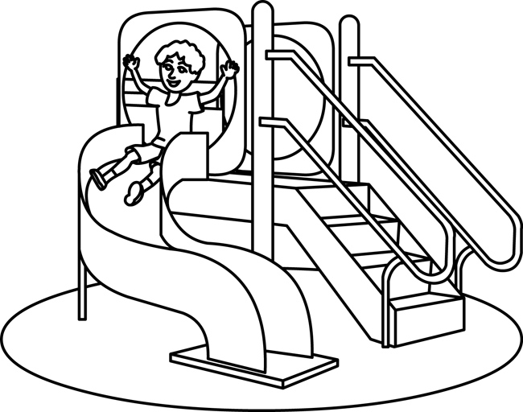
West Shore Lutheran School Handbook

West Shore Lutheran School’s Parent Handbooks for all ages and sessions can be found at www.westshorelutheran.com under the tab labeled “Registration Forms”. Please read the handbook and sign the statement below. If you would prefer a paper copy, please contact the school office.

The handbook includes all of the following information:
- Criteria for admission and withdrawal.
- Schedule of operation, denoting hours, days, and holidays during which the center is open, and services are provided.
- Fee policy.
- Discipline policy.
- Medication policy.
- Food service program.
- Program philosophy.
- Typical daily routine.
- Parent notification plan for accidents, injuries, incidents, illnesses.
- Exclusion policy for child illnesses.
- Notice of the availability of the center's licensing notebook.
- The licensing notebook contains all the licensing inspection and special investigation reports and related corrective action plans for the past five years.
- The licensing notebook is available to parents during regular business hours.
- Licensing inspection and special investigation reports from at least the past two years are available on the child care licensing website at www.michigan.gov/michildcare.
Parent Signature_________________________________________Date___________________

Child/Children’s Names__________________________________________________________

_____________________________________________________________________________

Elementary School Student Health Statement
This form is for children entering grades 1 – 6 only
Summer 2024

Child’s Name:__________________________________________________________

I,_____________________, the parent/legal guardian of the above-listed child, attest that my child is:

- In good health? If there are any activity restrictions please list here:
________________________________________________________________________________________________________________________________________________________________________________________________________________________________________________________________________________________________

- Current and up-to-date on all immunizations.

- The immunization record or appropriate waiver is on file for the child listed above at their elementary school.

Please list the name of the child’s elementary school in this box:

Signature & Date: ______________________________________________________________

